BCT Lab Softcopies

Name: Priya Rathod
Roll No.: 45
PRN: F22111052
Class: B.E. COMP 1 - Q Batch

Practical 1 (Installation of Metamask)
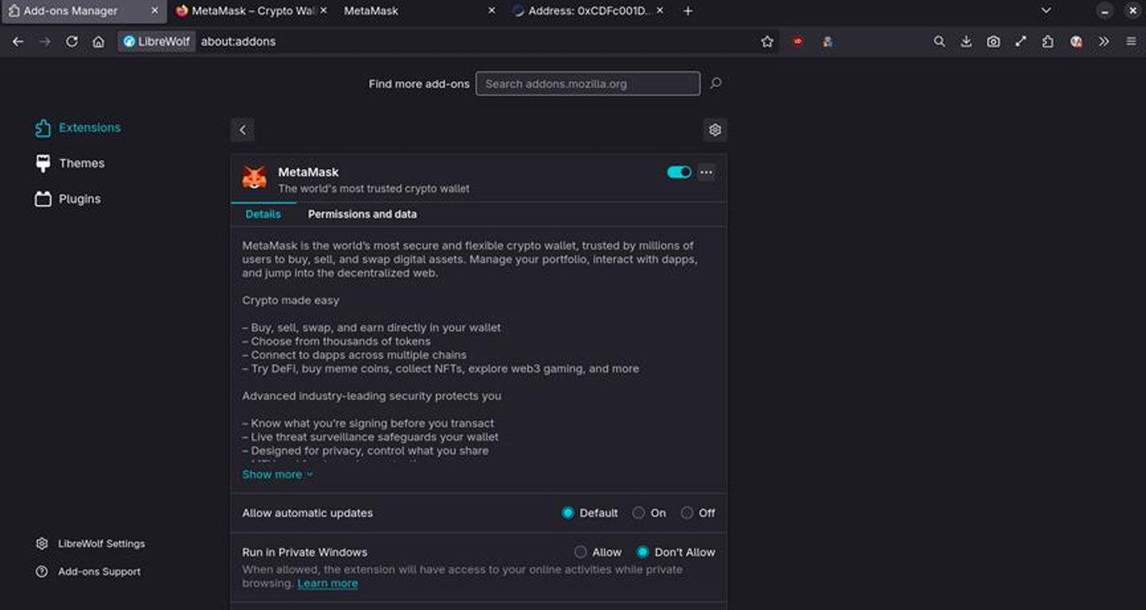

Practical 2 (Creating Wallet) 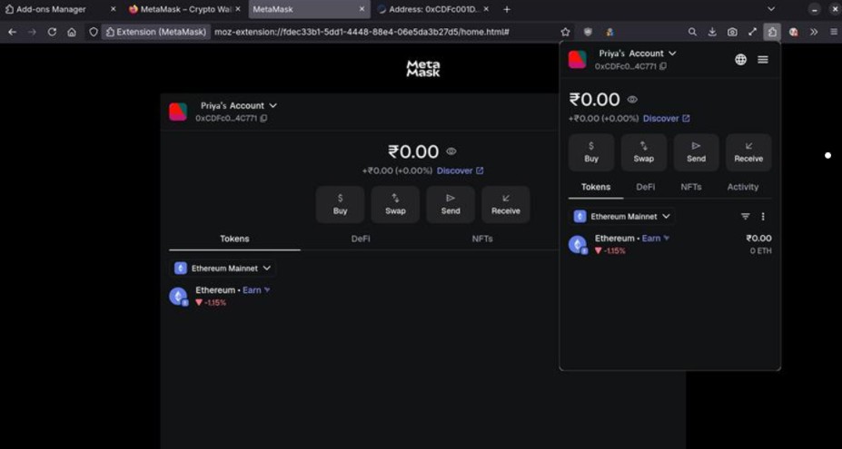

Practical 3 (Bank Account)

Code:

// SPDX-License-Identifier: MIT
pragma solidity ^0.8.20;

contract BankAccount {
mapping(address => uint256) private balances;

event Deposit(address indexed account, uint256 amount);
event Withdraw(address indexed account, uint256 amount);

function deposit() public payable {
require(msg.value > 0, "Deposit amount must be greater than 0");
balances[msg.sender] += msg.value;
emit Deposit(msg.sender, msg.value);
}

function withdraw(uint256 amount) public {
require(amount > 0, "Withdraw amount must be greater than 0");
require(balances[msg.sender] >= amount, "Insufficient balance");

balances[msg.sender] -= amount;
payable(msg.sender).transfer(amount);

emit Withdraw(msg.sender, amount);
}

function getBalance() public view returns (uint256) {
return balances[msg.sender];
}
}

Output:
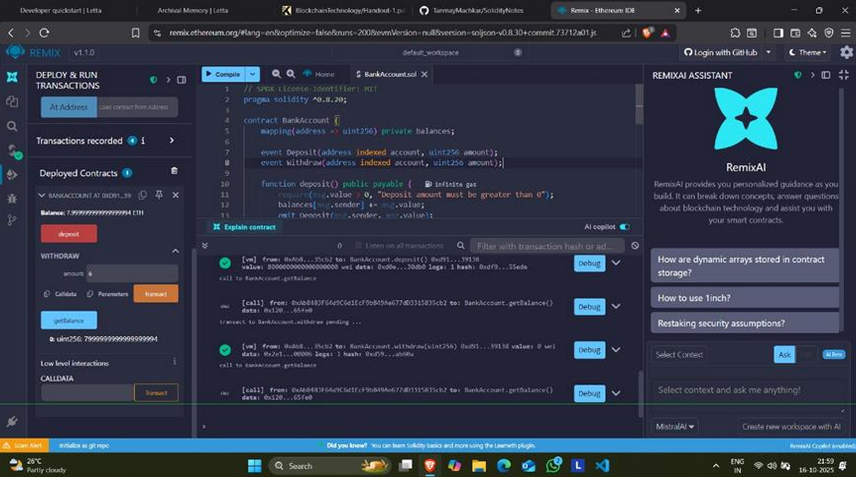

Practical 4 (Student Data)

Code:

// SPDX-License-Identifier: MIT
pragma solidity ^0.8.20;

contract StudentData {
struct Student {
uint256 id;
string name;
uint8 age;
string course;
}

Student[] private students;

event StudentAdded(uint256 id, string name, string course);
event FallbackCalled(address sender, uint value, string message);

function addStudent(uint256 _id, string memory _name, uint8 _age, string memory _course) public {
students.push(Student(_id, _name, _age, _course));
emit StudentAdded(_id, _name, _course);
}

function getStudent(uint256 index) public view returns (uint256, string memory, uint8, string memory) {
require(index < students.length, "Invalid index");
Student memory s = students[index];
return (s.id, s.name, s.age, s.course);
}

function getTotalStudents() public view returns (uint256) {
return students.length;
}

fallback() external payable {
emit FallbackCalled(msg.sender, msg.value, "Fallback function triggered!");
}

receive() external payable {
emit FallbackCalled(msg.sender, msg.value, "Receive function triggered!");
}
}

Output:
